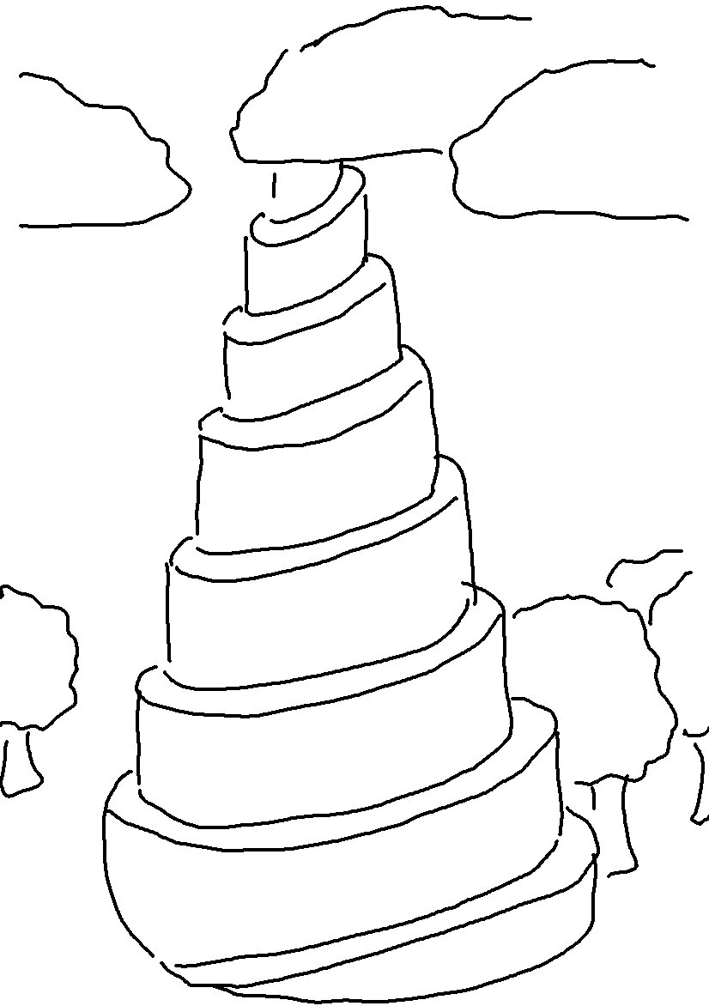
For the Lord corrects those He loves. Proverbs 3:12_{NLT}

